
NORTH AMERICAN TF-51D MUSTANG
The Greatest Fighter Aircraft in the World

Specifications

Wingspan 37 feet, 0 inches  Length 32 feet, 3 inches  Height 13 feet, 8 inches  Empty weight 7,450 pounds  Max. weight 11,200 pounds  Powerplant 1450 hp Rolls-Royce Merlin Series | Max Speed 440 mph  Service Ceiling 30,000 ft  Range 1,600 miles with two drop tanks  Armament 4 .50 cal. Browning Machine Guns  Crew 2
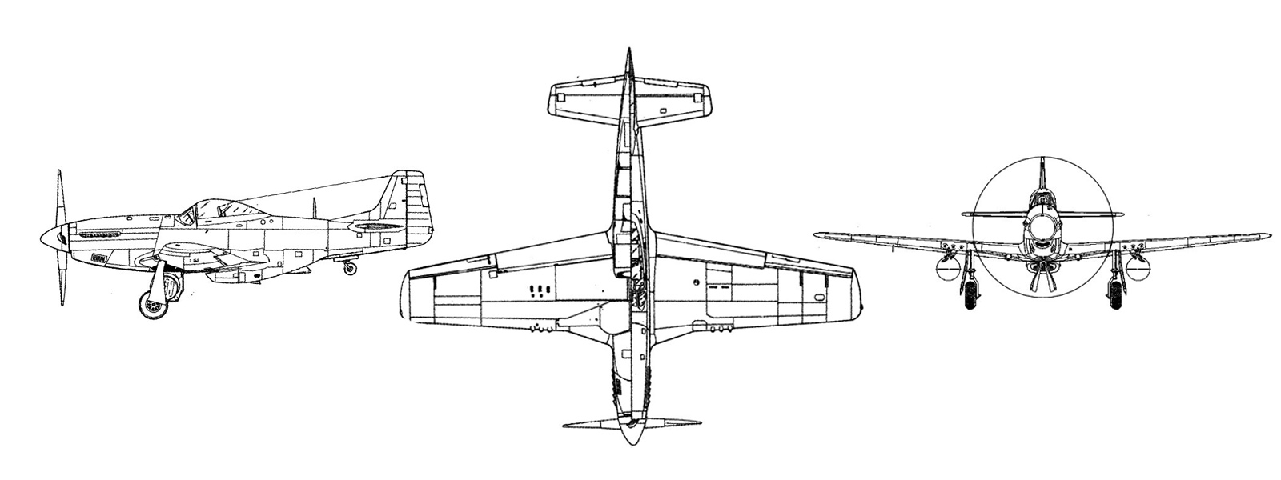
Background

Fast, well made with the ability to fly long distances, the North American P-51 Mustang became one of the world’s most successful and recognizable fighter aircraft. The bombing missions over the skies of Europe were taking very heavy losses from Luftwaffe fighters. The allied aircrews desperately needed an escort fighter that could stay with the bombers deep into enemy territory and back to base on every mission. The P-51 Mustang was the immediate choice. Within a very short period, the P-51 was affectionately nicknamed by the bomber crews as their “Little Friend”. The P-51 Mustang and the pilots who flew them saved countless lives in the skies and on the ground, and perhaps turned the tied of the war.

North American developed the P-51 in the early 1940s. The first prototype flew on October 26th, 1940 and was designated the NA-73X. The British ordered 620 of the aircraft and designated them the Mustang I. The aircraft entered service starting in February 1942. The United States Army Air Force evaluated two Mustang I’s that they designated XP-51’s. They placed and order for 500 of the aircraft and used in a dive bomb role. In this function the USAF designated them A-36A Apaches before delivery. The P-51A was brought into production when the USAAF replaced the 1,150 horsepower Allison V-1710-F3R in the A-36 Apache with the improved 1,200 horsepower Allison V-1710-81. The Collings Foundation’s P-51C is powered by the Packard built Rolls-Royce Merlin engine. The
P-51B and C were the first fighters to escort the allied bombers all the way to Germany and back.

Starting in 1943 North American Aircraft started with production of 1,988 P-51Bs from its Inglewood, CA factory. They built and additional 1,750 aircraft from their Dallas, TX facility and designated them as
P-51Cs. Starting with the P-51C-5 production block, North American switched to the more powerful Merlin V-1650-7 engine. The new line, designated NA-109, P-51D, was started after the USAAF ordered 2,500 in July 1943. Interesting is that the XP-51D did not have a test flight until November 17, 1943, well after the first order was placed. Deliveries to fighter units began March of 1944 and a good supply was on hand for the Normandy Invasion, or D-Day. The signature change in the P-51D line was the new bubble canopy.
After WWII, the USAAF consolidated much of its fighter aircraft. Most piston powered fighters served substantially reduced roles as more advanced jet powered aircraft emerged. The Mustang still proved useful serving in the Korean War and state-side in the Air Force Reserves and National Air Guard. TF-51D Mustangs (two-seat trainers) were used to train fighter pilots until the jet-trainers such as the T-33 Shooting Star were fully utilized. The Foundation’s TF-51D #44-84655 is one of three original TF-51Ds remaining in the world. This fighter is painted in its original markings as a West Virginia Air Guard, 167th Fighter Squadron P-51 called “Toulouse Nuts.”
2016 Oshkosh AirVenture Grand Champion, “Toulouse Nuts” is one of the world’s finest TF-51D restorations to date. Tens of thousands of hours went into rebuilding this fighter to “brand new” condition. Every surface, rivet, wire and instrument is perfect. The 1450 hp Merlin engine looks like it just came off the factory floor. Think of this fighter as a flying sculpture you can experience! We offer Flight Training in “Toulouse Nuts.” See our flight coordinator for details and schedule.
Collings Foundation relies solely on contributions and donations to off set the operation cost of several thousand dollars per flying hour. These contributions ensure the future of the aircraft and keep “Betty Jane” flying, as a symbol of American patriotism and as a educational tool for our future generations to learn more about World War II and aviation history.

For More Information:
The Collings Foundation
P.O. Box 248
Stow, MA 01775

Tel: 978.562.9182
Fax: 978.568.8231
Email: info@collingsfoundation.org

Website: www.collingsfoundation.org

